

**North Court Redevelopment Construction Update**

**November 3, 2023**

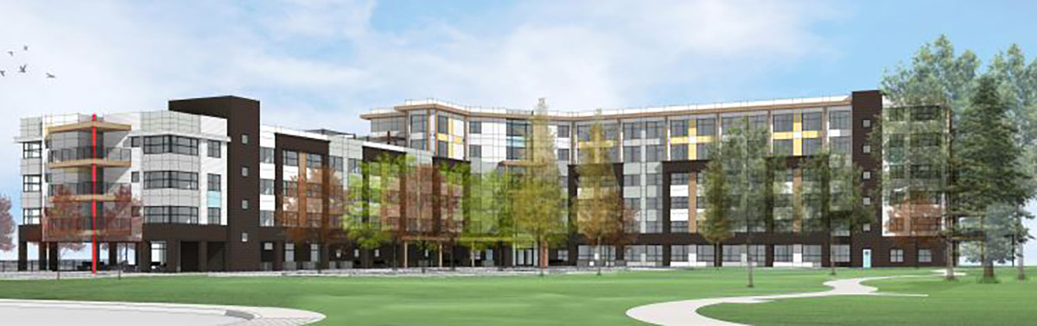

Architectural rendering of North Court 152-unit seniors' affordable rental housing complex.

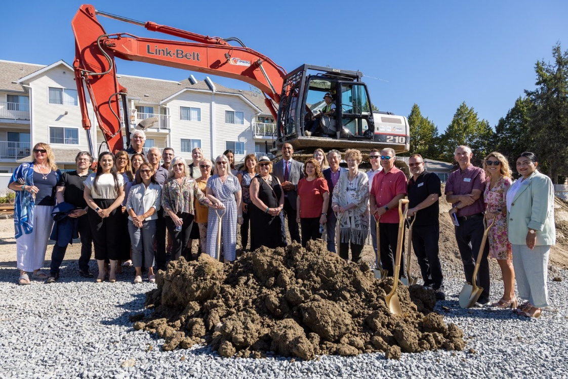

Since the ground breaking ceremony on August 16 significant progress has been made including most of the excavation and concrete work on the below grade retaining walls has been completed.

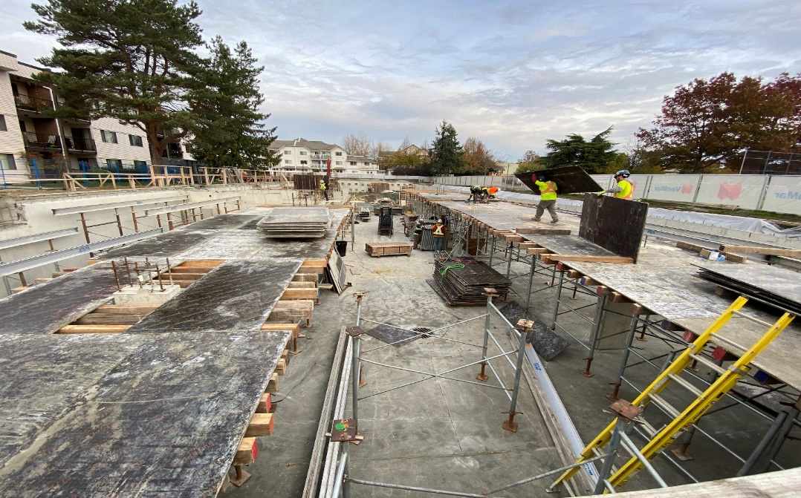

Construction workers place forming boards on top of concrete pillars which will become the parkade.

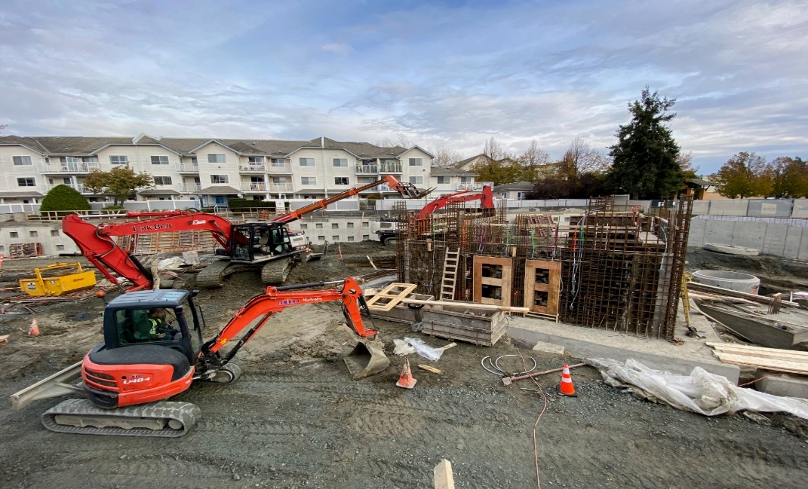

The concrete foundational slab has been poured with reinforcing bar (rebar) for the main elevator shaft is beginning to take shape that will eventually rise six stories in height.

When completed, KinVilage North Court Redevelopment will provide new affordable homes for older persons. This housing development is a result of a partnership between the Government of British Columbia and KinVilllage. Located at 1054 - 54A St., KinVillage Apartments will have 145 one-bedroom and seven two-bedroom homes. All units will be adaptable or accessible, allowing the suites to be easily and inexpensively modified to meet residents’ needs as they age. The development will also include 77 parking stalls, amenity and program space, an outdoor rooftop deck with greenspace, as well as scooter, bicycle and storage lockers. The new build will feature a 5,000 square foot Day Program for Older Adults enabling older persons to age in their homes longer while providing respite for their family caregivers.

For more information on the construction of North Court please contact ea@kinvillage.org